**Hungry Heroes**

Introduction: Hungry Heroes is an online platform where customers can order food items from various restaurants. On this platform, restaurant owners can add their available food items to their menu list, from which the customer can choose their desired item to order. The purpose of this project is to make people’s lives easier. By using this platform, both customers and restaurant owners would benefit. Customers can order food from home, and restaurants can also get some extra customers to increase their profits even more.

Methodology: This project is built using the C#.Net architecture. Windows Form is used to design the front view, where every user will interact. All the data for this project will be stored in the database. Microsoft Visual Studio Community’s internal SQL database is used for this project. All the database tables are created using Microsoft Visual Studio Community's internal SQL database tools.

Front End Designing Process:

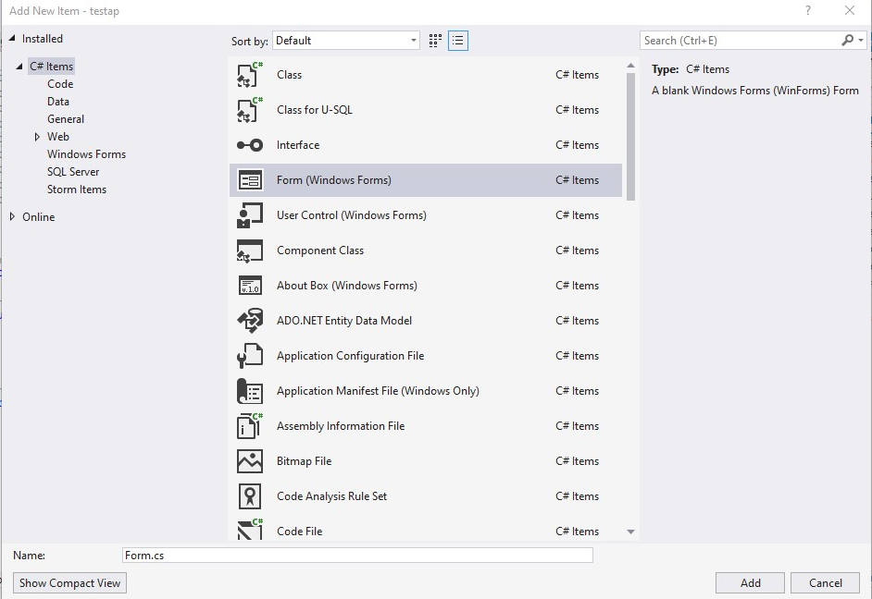

Windows Form is used for most of the design, which contains various other components for smoother interaction and for a better outlook on the design.



Some designs are used using user-controlled Windows Forms. The benefits of using this user control window are that we can use it as a single component and implement this whole design in a Windows Form as a single reusable component.

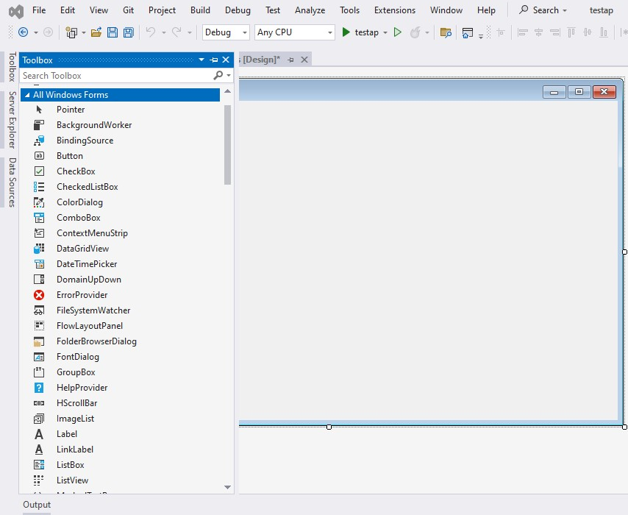All the components are taken from this toolbox. This project used several types of components. All the used components names are:

* Button
* Radio Button
* Label
* Link Label
* Check Box
* Combo Box
* Data Grid View
* Date Time Picker
* Text Box
* Panel
* Picture Box

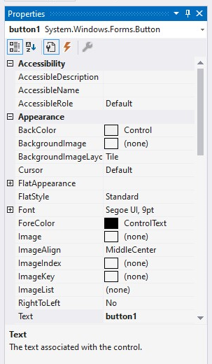

All the components are changed to their appropriate design using this properties window. Such as the Fore Color option, which is modified for changing the text color, and the Back Color option, which is used for changing the components back colors as needed for proper design.

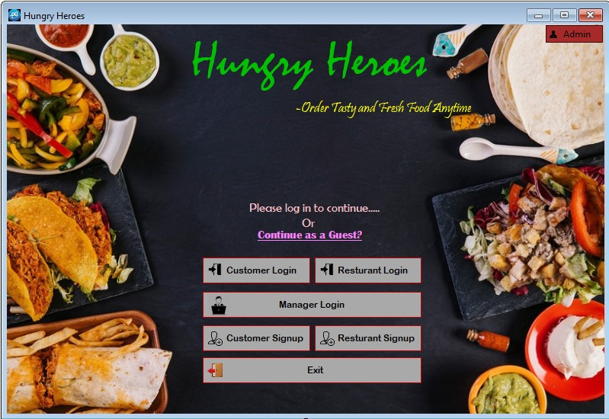Design Results with Functionalities:

Label

Buttons

Link Label

This is the initial page of our Program. There are buttons, labels, and a clickable link label. Different buttons will perform different tasks.

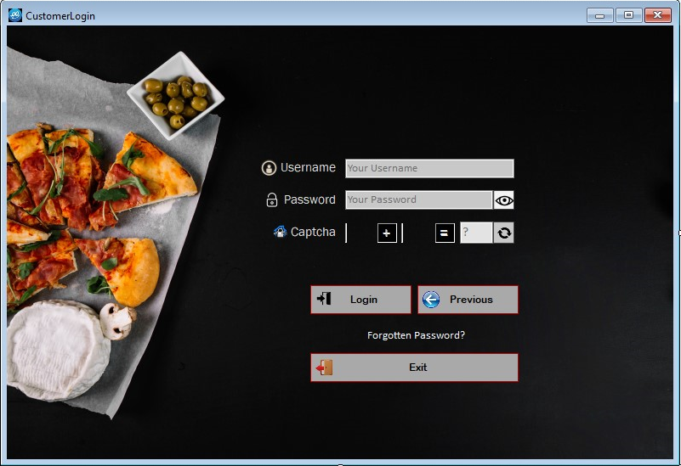→If a customer press Customer Login button from **First Page**, Customer Login Page will be opened, and first page will be hidden.

Textbox

Label with Icons

Button

In this customer login page there are text boxes, buttons, and labels with picture as an icon. In this page, user will enter its username and password in the textbox. A user can view his/her password by clicking that eye icon beside password textbox field. There is also a captcha for preventing spamming passwords. User can change captcha by clicking that re-captcha button beside captcha answer entering textbox. When customer will press Login button, if the password and username is correct it will go to the customer’s home page, otherwise it will give an error message. If the customer forgot his/her password, it can be backup by clicking that 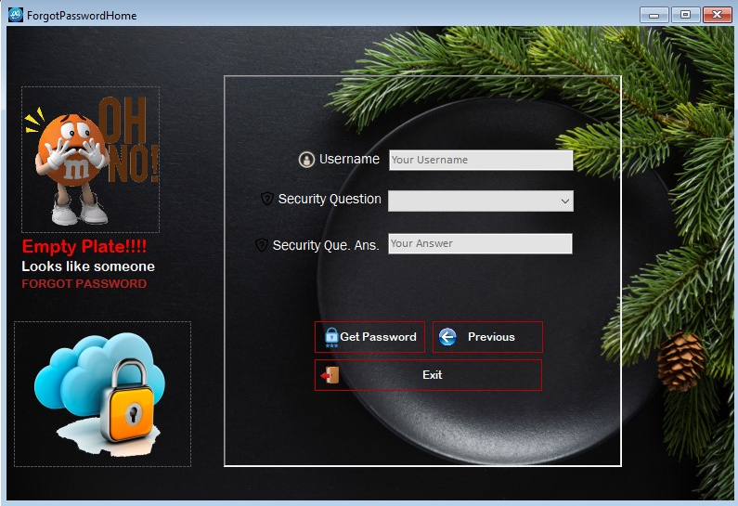“**forgot password label**”. It will take the customer to a new page by hiding this one.

Combo Box

Picture Box

Panel

This is the forgot password page. There are several components such as picture box, textbox, buttons, labels, combo box and panels. Users will enter his/her username and will select Security question from combo box and will write its correct answer in the text box that they provided during registration. If all information is correct the password will show otherwise it will give an error message.

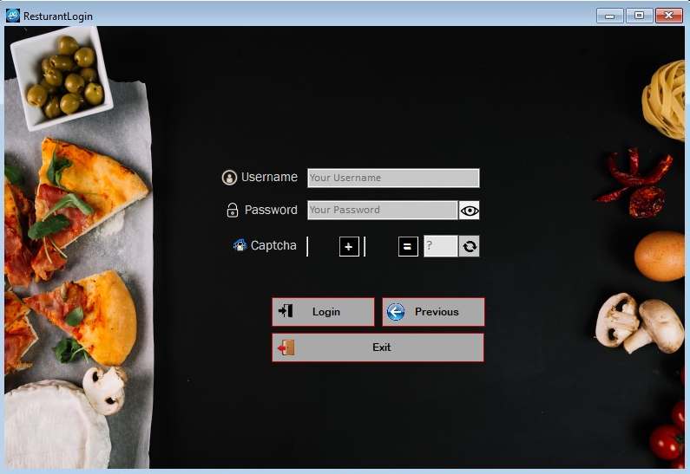→If a customer presses Restaurant Login button from **First Page**, Restaurant Login Page will be opened, and first page will be hidden.

From this page restaurant owner can enter its correct username and password to login into his/her account. Also, there is a captcha like customer login page along with password view and hide button.

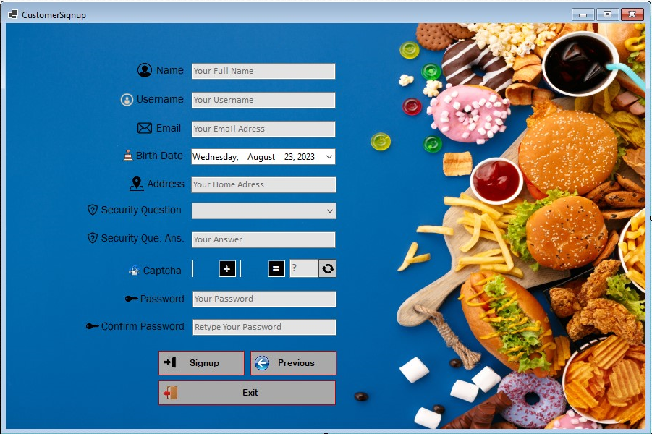→If a customer presses Customer Signup button from **First Page**, Customer Signup Page will be opened, and first page will be hidden.

Date Time Picker

New customers can create an account from this page. There are several components like previous pages along with date time picker which is used to pick a specific date from calendar. Here the date-time picker is used to pick birthdate of the customer. Users need to fill in all the details in order to registration or sign up. Users need to pick a unique username which is not used by any other members who uses this app. Their age should be more than 12 years. Age will be verified through the birthdate. Users need to enter a password which is at least 6 characters long and contains a capital letter and a number. If all the details are acceptable then the sign up will be completed through the signup button.

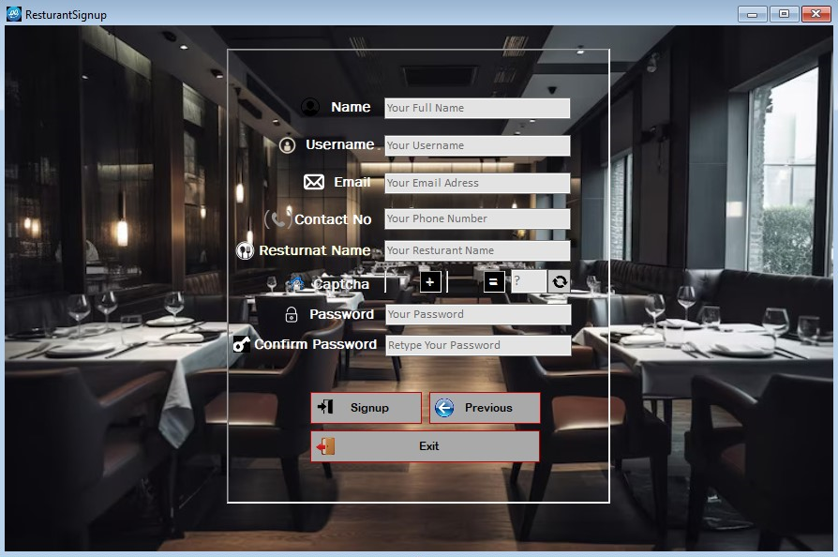→If a customer presses Restaurant Signup button from **First Page**, Restaurant Signup Page will be opened, and first page will be hidden.

New Restaurant owner can create account from this page. Users need to fill in all the details in order to registration or sign up. Users need to pick a unique username and email which is not used by any other members who use this app. Email should be in the right format otherwise it will give an error. Users also need to enter a valid phone number which contains 11-digit number only. The password needs to be at least 6 characters long and needs to contain a capital letter and a number. If all the details are acceptable then the sign up will be completed through the signup button.

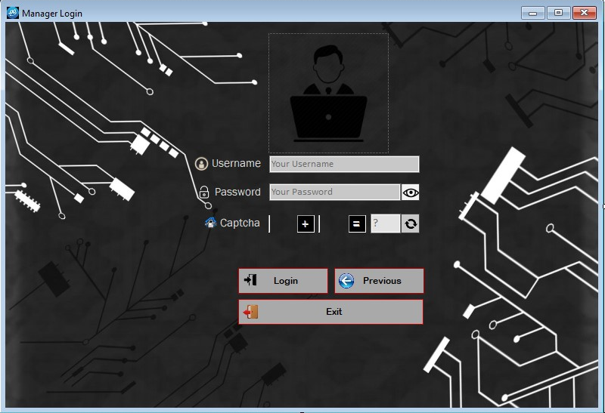→If a customer presses Manager Login button from **First Page**, Manager Login Page will be opened, and first page will be hidden.

From this page managers can enter its correct username and password to login into his/her account to control customer and restaurant owners everything. Also, there is a captcha like other login page along with password view and hide button.

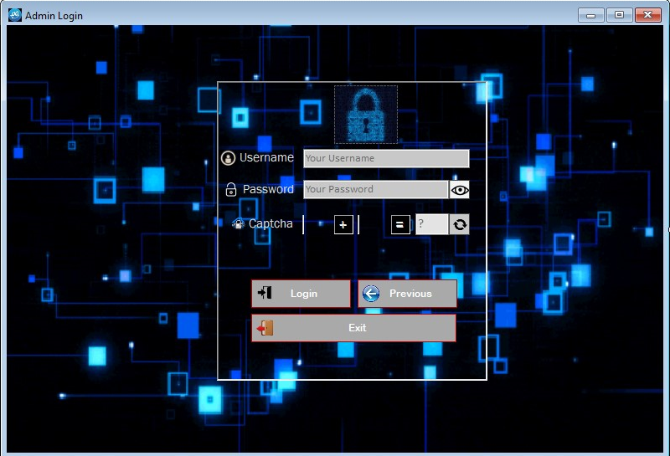→If a customer presses Admin Login button from **First Page**, Admin Login Page will be opened, and first page will be hidden.

From this page Admin can enter its correct username and password to login into his/her account to control everything. Also, there is a captcha like other login page along with password view and hide button.

Panel

Radio Button

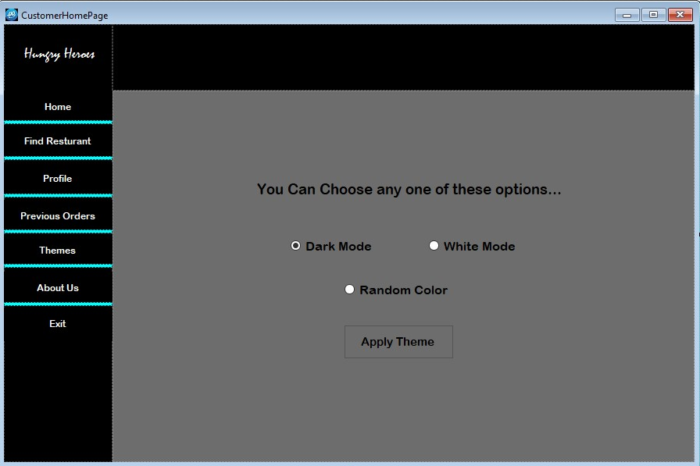This is the customer home page design. It consists of several components like previous designs along with radio buttons. Those blue panels are used for highlighting button press. Initially those panels visibility is set to false. When a specific button is pressed then only that panel under the button is highlighted.

When the home button is pressed a user control named HomeReuse is called and fills all the dark gray panel area.

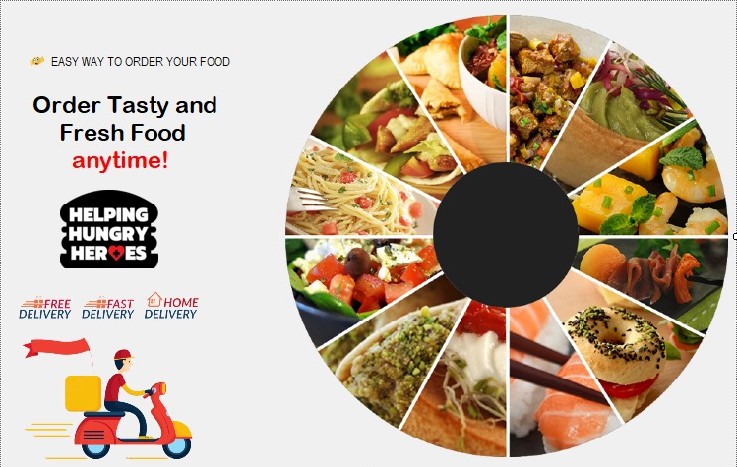

When the Find Restaurant button is pressed a user control named FindResturantReuse is called and fills all the dark gray panel area.

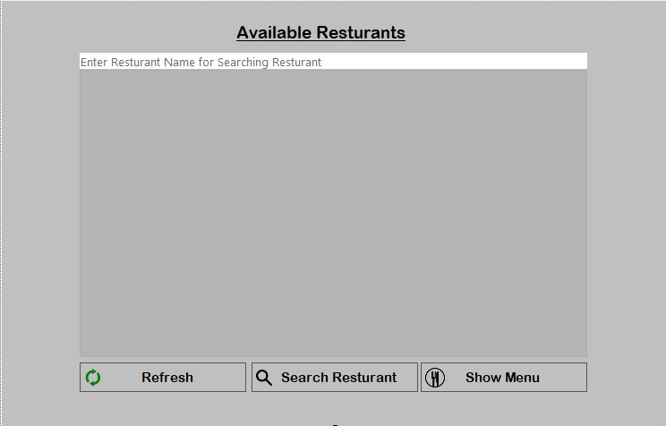

Data Grid View

In this user control all the available restaurants will be shown. Customer can select a restaurant and show its menu by clicking the show menu button. Customers can also search restaurant by restaurant name. The refresh button is used for refreshing this page to show all the available restaurant names.

When the profile button is pressed a user control named ProfileReuse is called and fills all the dark gray panel area.

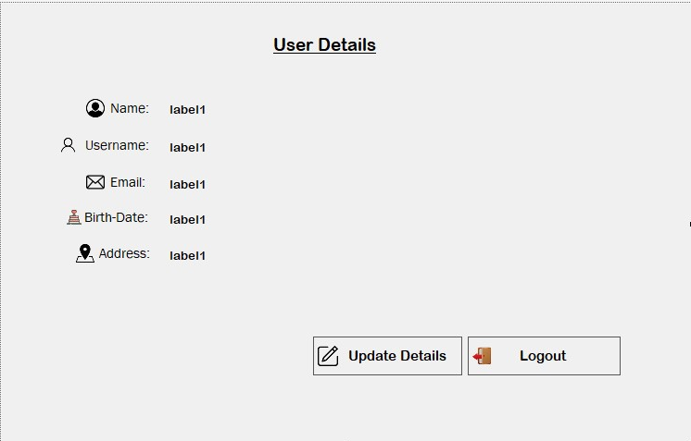

In this user control panel, all the details of the customer are shown. Customers can logout by clicking logout button. Customers can also update their details by clicking the update details button from this panel. This will open a new panel which will allow customers to edit their details.

When the Previous order button is pressed a user control named PreviousOrderReuse is called and fills all the dark gray panel area.

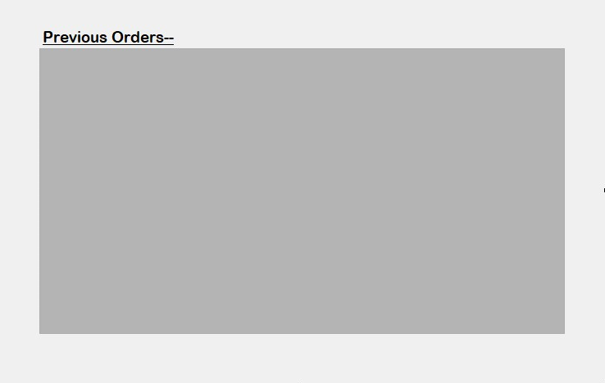

Data Grid View

In this user control panel, all the previously placed order by the logged in customer will show.

When the Themes button is pressed all the user control will be removed and those radio button and apply themes button will be visible. Customers can choose 3 different modes. Default is dark mode. White mode will change the background theme to white and random color mode will select a random color from the color code that is stored in an array of this class.

When the About Us button is pressed a user control named AboutUsReuse is called and fills all the dark gray panel area.

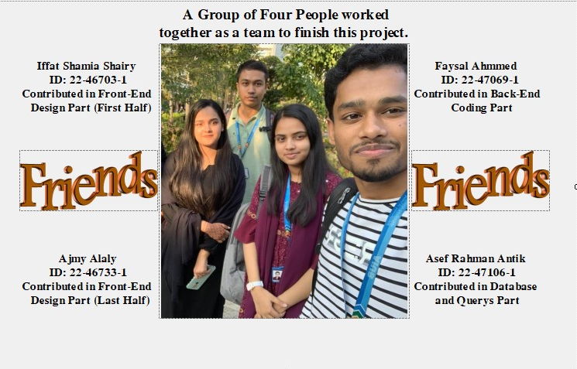

In this user control panel, all the details and contribution of those who built this project will be shown.

When the Exit button is pressed the program will be terminated.

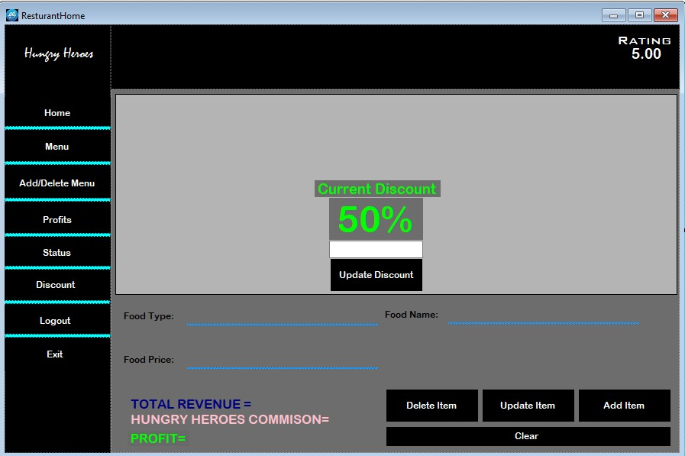

This is the restaurant owner home resign. Gray panel is by default false visible. In the upper right corner, there is a restaurant rating display(label) which shows all the ratings average that the customer gave after ordering food.

When the home button is pressed a user control named HomeReuse is called and fills all the dark gray panel area like Customer Home Page.

When the menu button is pressed all the menu item that is added previously by the owner will be shown in data grid view.

When the add menu button is pressed all the text box under the data grid view will be visible. When users select a specific item, the text box will be filled with that item’s details. Then the user can customize the menu item and update that using the update button. To delete items, user need to select an item and press delete. To add new items, the user needs to insert a food item details which are not previously added in the menu. The clear button will erase all the text from the text box.

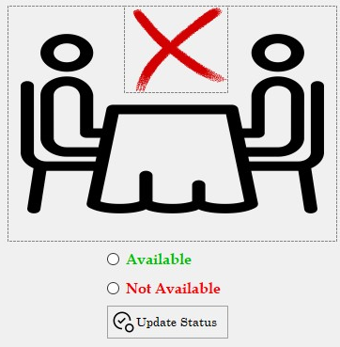When the profit button is pressed all the bills that have been made from this restaurant will be shown in the data grid view. Also, the total sells and total profit with Hungry-Heroes commission will be shown.

When the status button is pressed a user control named ResturantAvailability is called and fills all the dark gray panel area like Customer Home Page.

Customer can select their availability through radio button and update its status. When not available is clicked the cross icon will show, otherwise it will remain hidden.

When the discount button is pressed the discount percentage and a text box will show. Users can enter discount amount and update their discount percentage.

When the logout button is pressed, the customer will receive a confirmation SMS, it confirmed then it will be logged out otherwise the logging out operation will be cancelled.

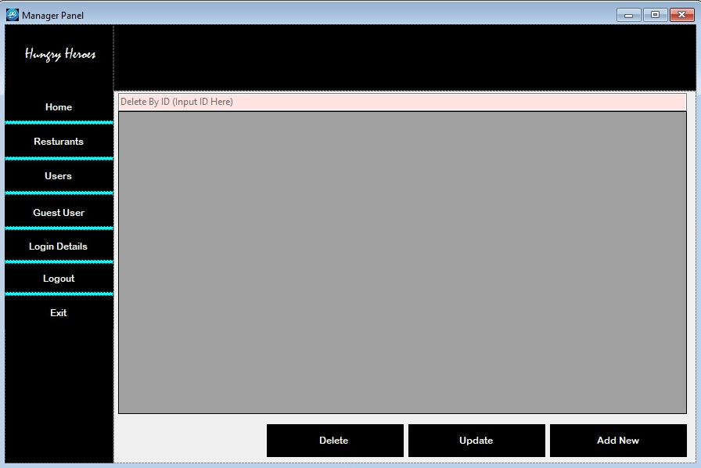

This is the manager home page panel.

When the home button is pressed a user control named AdminHomeReuse is called and fills all the dark gray panel area like previously discussed Pages.

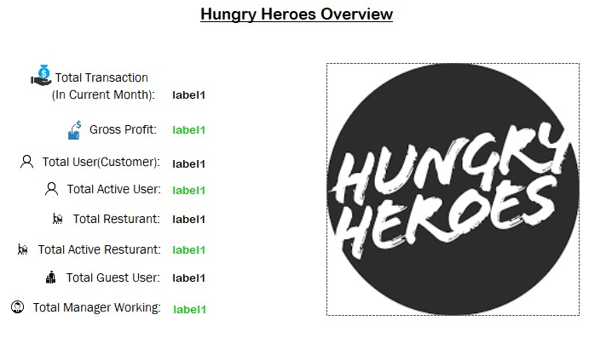

In this home panel all the necessary details about this app will be shown. In total transaction, summation of all the transaction in the current month will show. In gross profit, the profit that is earned from restaurant commission will be shown. In total users the total account that has been created will show and in active users, the users that are currently using the service will show. Same for the restaurant owners and managers also.

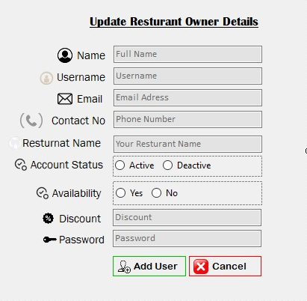When the user will press restaurant button, then all the details of the restaurant owners will be shown. Managers can also search for restaurant owners by their username. Managers can update, delete, and add new restaurant owners. When manager will try to update or add new restaurant owner, a new form will be open, and this form will be disabled but remain visible.

From this page, managers can update or add new restaurant owner.

When the user will press User button, then all the details of the customer will be shown. Managers can also search for customers by their username. Managers can update, delete, and add new users. When manager will try to update or add new restaurant owner, a new form will be open, and this form will be disabled but remain visible.

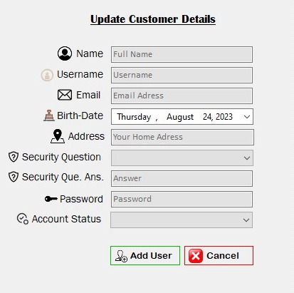

From this page, managers can update or add new customers.

When managers press the guest user button, then all the details of the users who ordered food as a guest will be shown.

When managers press the login details button, then all the login details of customers, restaurant owners, and guest users will show. Managers can select if they want to show a specific type user’s detail.

When the logout button is pressed, the manager will receive a confirmation SMS, it confirmed then it will be logged out otherwise the logging out operation will be cancelled.

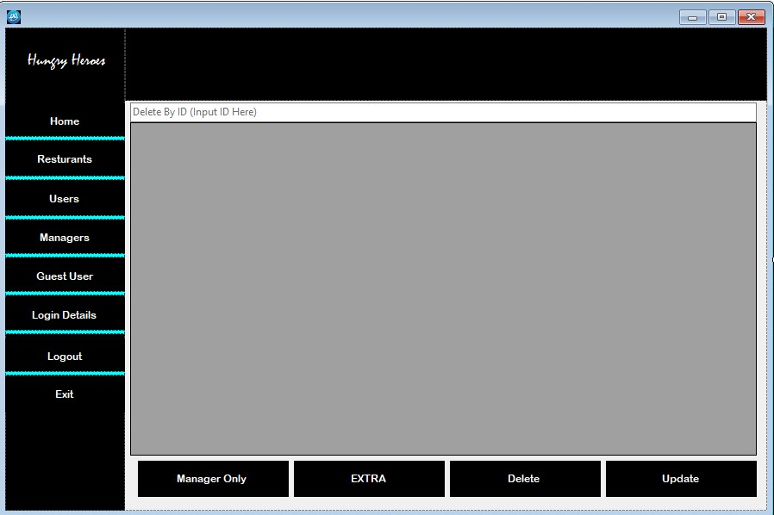

This is the admin home page. Admin can do all the work that manager can do with some extra. Admin can add new managers or delete managers. Admin can see managers login details also. Admins delete, add, and update is little bit different than managers. When admin tries to update, delete, or add a new user, there will be no new form that will open, instead admin can do all these things inside DataGrid view.

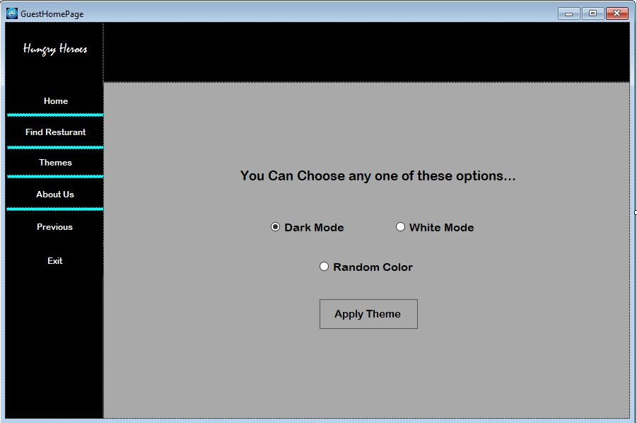

This is the guest home page. Similar functionalities as customer home page with some limitation. They cannot see their profile as they don’t have their profiles. Guest users can also order food, change the theme, search restaurants etc.

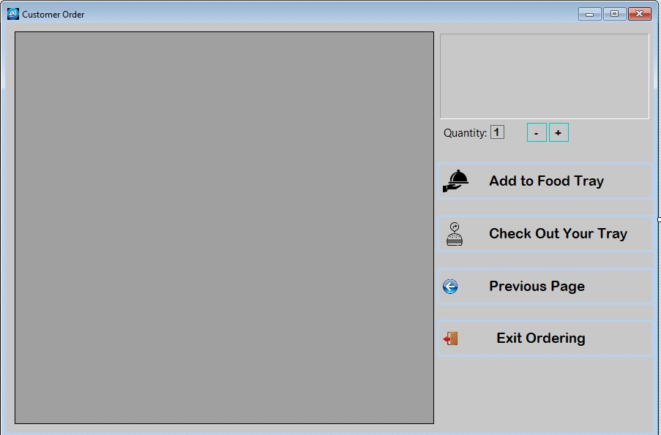

This is the customer order page. Customer and guest user can order from here. All the menu items from the selected restaurant will be shown in the data grid view. Users can select an item and add to food tray by clicking add to food tray button. User can increase or decrease quantities also by clicking +/- buttons. Minimum quantity can be 1, and maximum is 10. User can add a total 5 items at a time. All the items will be stored inside a **List.** There are 3 lists. One is for food item name, one for price and the last one is for storing quantity. When the checkout button is clicked a new window will pop up.

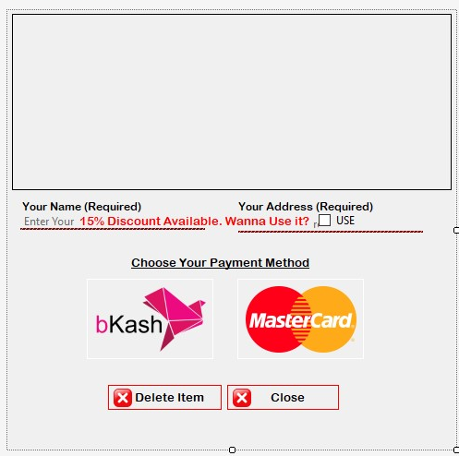The name and address field will be visible only for guest users. Without filling in those they can’t order. The discount will only show for customers if they are available for it. To be available for a discount, they need to order 10000+ in the current month and they shouldn’t have claimed a discount in that month. In the data grid view all the value stored in list will show along with total and discounted price. If a customer checks the use box, then the discount price will apply. Customer can delete item by selecting an item from the data grid view and pressing delete. They can’t delete the total amount row by mistake. They can choose two payment methods. bKash or MasterCard.

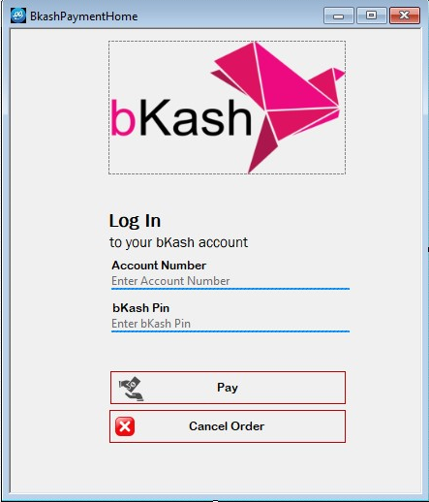If a customer chooses bKash payment method, then this page will show. Here users need to input their phone number and pin for bKash account. Pin should be more than 5 digits and only numbers. And numbers should be 11-digit numbers only. If customers cancel the order, then it will take them to the customer order page.

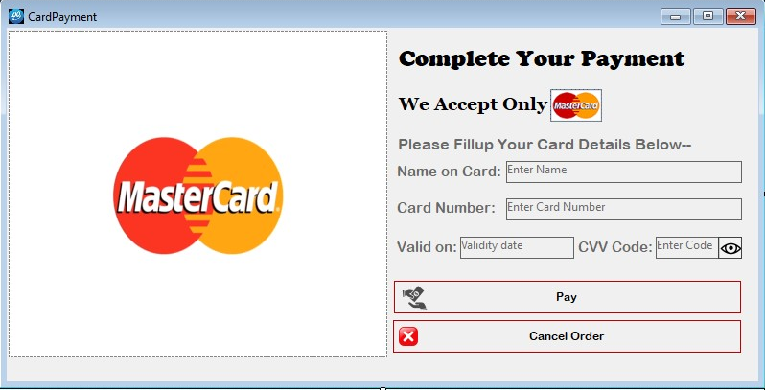

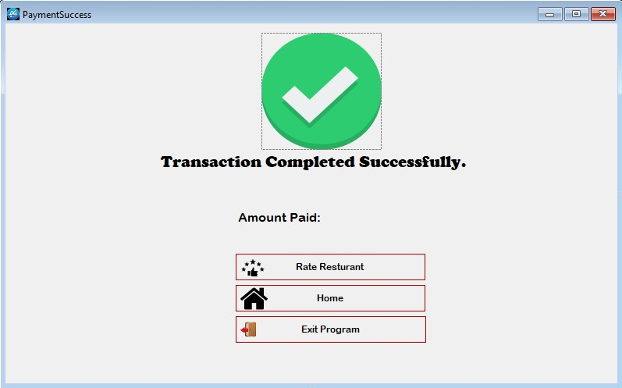If users choose the master card method, then this page will open. Here users need to input the card details correctly. The card number should be 16 digits number only. CVV code should be 3 digit exact. CVV code will show password character. It can be turned off by clicking the eye icon button beside CVV code textbox.

After successful payment this page will show. From this page users can rate restaurants. Only customers can rate. Guest users can’t rate restaurants. Rating can be done only one time. If users try to rate 2 times from this page, it will show a warning message box. By clicking the home button users can go back to the customer home page.

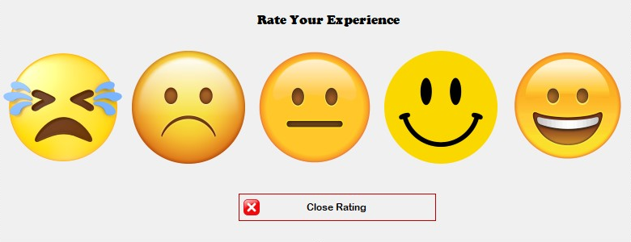

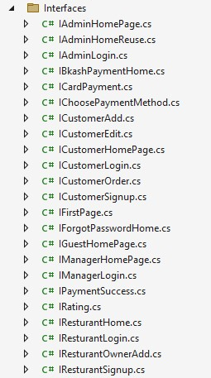This is the rating page. Users can use this page to rate restaurants based on their satisfaction level of 1 to 5. Where 1 is the worst and 5 is excellent. If a user doesn’t want to rate, they can just simply close this page without giving any rating.

Also, interfaces have been added to the project to maintain functionalities. As interfaces define all methods of a class, its makes developer easier to understand what method is needed for a class for proper functioning.

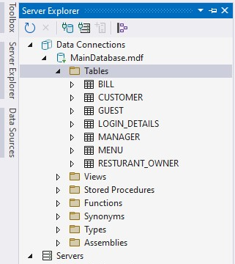Database Designing Process:

All the tables of the database are designed through Microsoft Visual Studios built in database SQL server. Also 3 sequences are created to insert primary values for 3 specific tables.

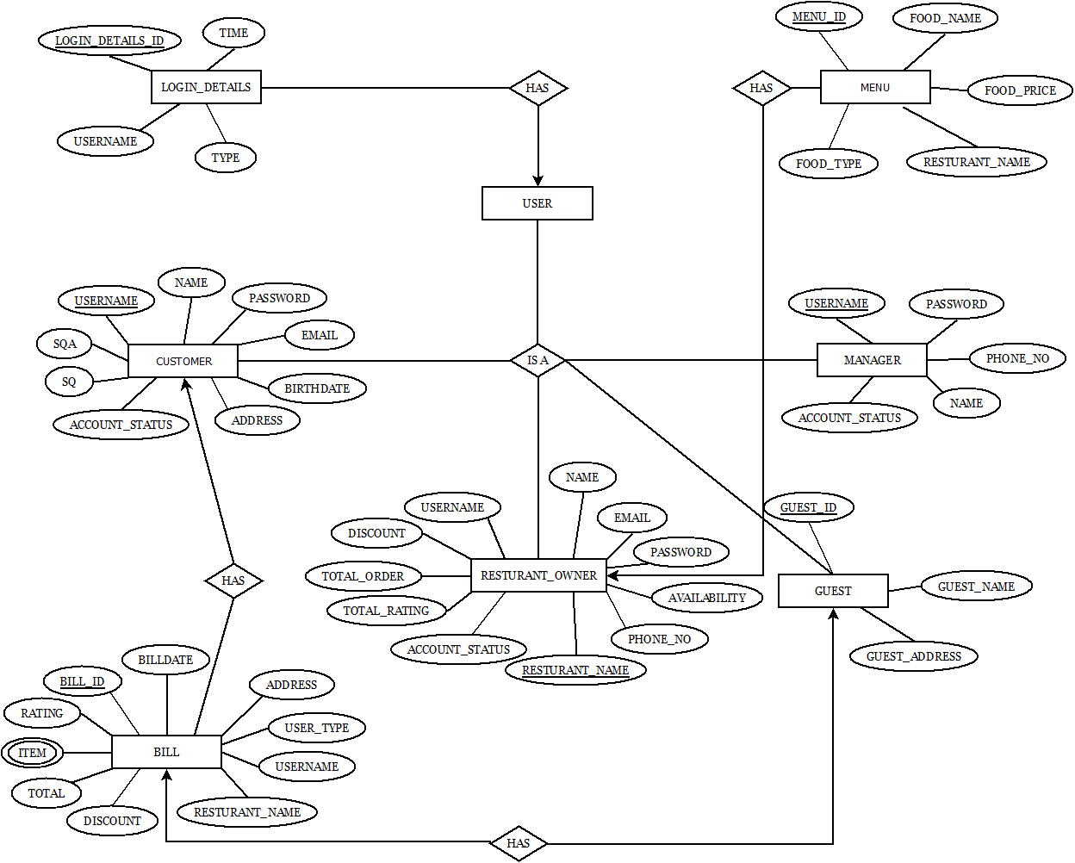Database ER Diagram:

Conclusion: "Hungry Heroes," a C# project, is a cutting-edge online food delivery service that seamlessly connects food enthusiasts with their favorite restaurant. By the power of C# programming, the project offers a user-friendly platform where customers can explore a diverse range of options, place orders effortlessly, and payment securely. The project not only prioritizes customer convenience but also empowers local restaurants by providing them with a digital storefront to expand their reach. Through its innovative approach, there are some limitations in this program. Restaurant owners can’t insert any food item photo even if they want to. There is no place for photos in the database. Also, this project can be extended further. Real-time order tracking can be added. A new type of user, delivery man can be added. Also, our limitation can be solved by giving permission to the restaurant owner to insert photos. In future we will improve this project and make this project even more user friendly.

A glance of those people details who made this project possible:

|  |  |  |
| --- | --- | --- |
| No. | Name | ID |
| 1 | Iffat Shamia Shairy | 22-46703-1 |
| 2 | Ajmy Alaly | 22-46733-1 |
| 3 | Faysal Ahmmed | 22-47069-1 |
| 4 | Asef Rahman Antik | 22-47106-1 |

*-Report written by Iffat Shamia Shairy*

: